**GOVERNMENT OF TAMILNADU**

**Naan Mudhalvan – Project Based Experiential Learning**

Project Report on

**IREVOLUTION: A DATA-DRIVEN EXPLORATION OF APPLE'S IPHONE IMPACT IN INDIA**

**Submitted by**

**G. HARINI (973D5E4E0EE3A2B888644AE052F6981F)**

**T. MONAS (401A1AE42OF7B8DB94E4E8786F64E6AF)**

**N. VANISHA (786DE202D98094284024BC18ACC478D1)**

**M. NIVETHA (5FA230D7B9B465F9CCA451D02B7D24B2)**

**(TEAM ID : NM2023TMID07178 )**

**Under the guidance of**

**Dr. M. GAYATHRI M.Sc., Ph.D**

**Guest Lecturer**

**Department of Mathematics**

GOVERNMENT ARTS COLLEGE FOR WOMEN,

(Affiliated to Mother Teresa Women’s University, Kodaikanal)

Reaccredited with “C” Grade by NAAC

NILAKOTTAI-624 208

**1 INTRODUCTION**

1.1 **Overview**

The world has changed as a consequence of the increasing use of smart phones, which have improved communication, connected people, and revolutionized many different businesses. With its main product, the iPhone, capturing markets around the world, Apple Inc. has emerged as a prominent player among the top smart phone makers. India, one of the economies with the greatest economic growth, has seen a tremendous increase in smart phone usage, making it an interesting market to study the effects of Apple's iPhone.

In order to shed light on important factors like market penetration, customer preferences, economic ramifications, and societal changes, this research report will perform a data driven investigation of the impact of the iPhone in India. This study will offer invaluable insights into the transformative impact of the iPhone on India's technological landscape and the lives of its consumers by using advanced data analytics techniques and analyzing large datasets.

Apple has a special chance to increase its market share and develop a significant presence in India thanks to the country's large population and rising smart phone adoption. Each new iPhone model unveiling generates excitement and anticipation among Indian buyers. By utilizing the plethora of information already accessible, this research aims to go beyond conjecture and anecdotal evidence in order to develop a thorough knowledge of the effects of the iPhone.

1.2 **Purpose**

The project's business needs call for data analysis and visualization in order to understand how Apple's iPhone has affected India. This entails looking at customer choices, market penetration, sociological developments, and economic effects. Tableau visualizations should be interactive, understandable, and educational so that stakeholders can make data-driven decisions and comprehend the impact of the iPhone on the Indian market.

**2 Problem Definition & Design Thinking**

Analysing the impact of Apple iphones in india and creating Dashboard, story using tableau.

2.1 **Empathy Map**

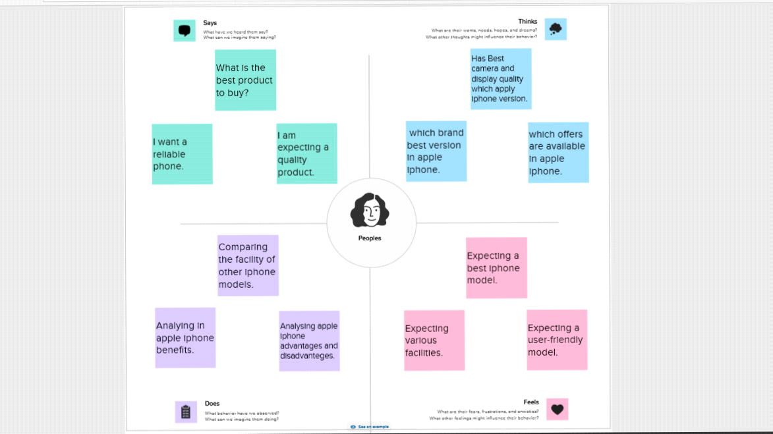

2.2 **Ideation & Brainstorming Map**

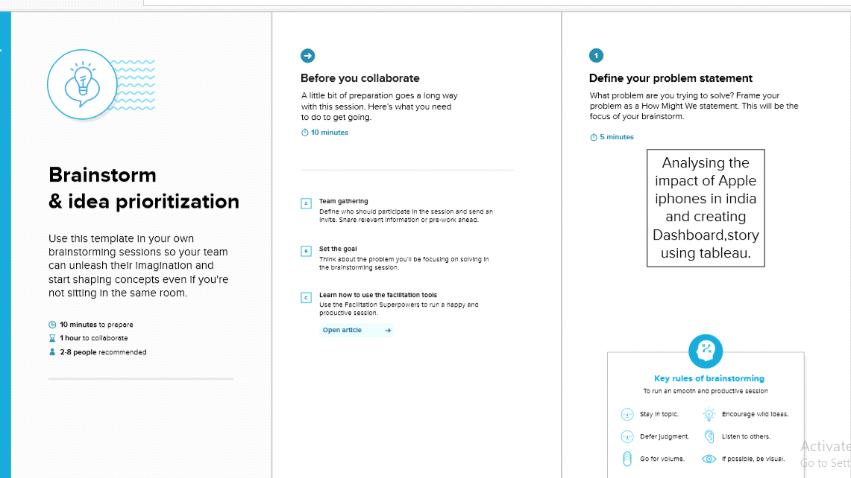

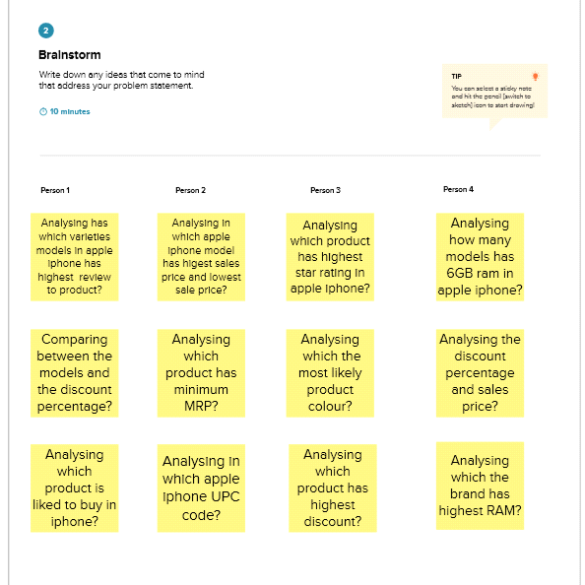

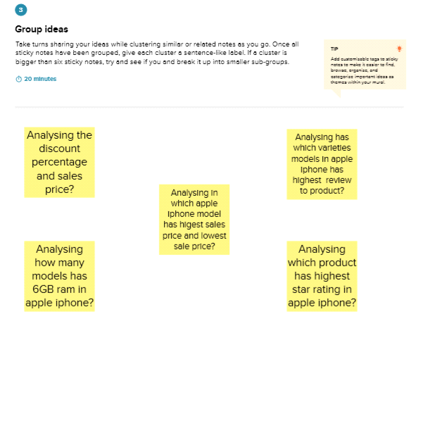

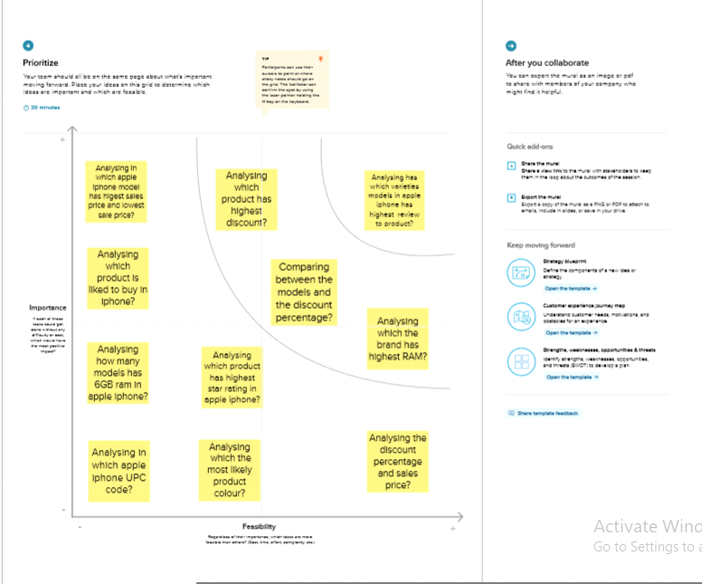

**3 RESULTS**

**Activity** 1:

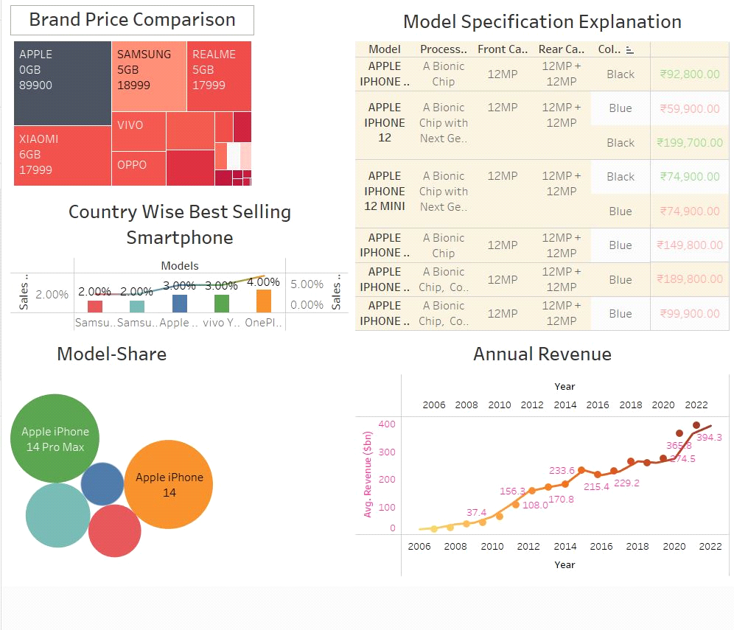

**Activity 2**

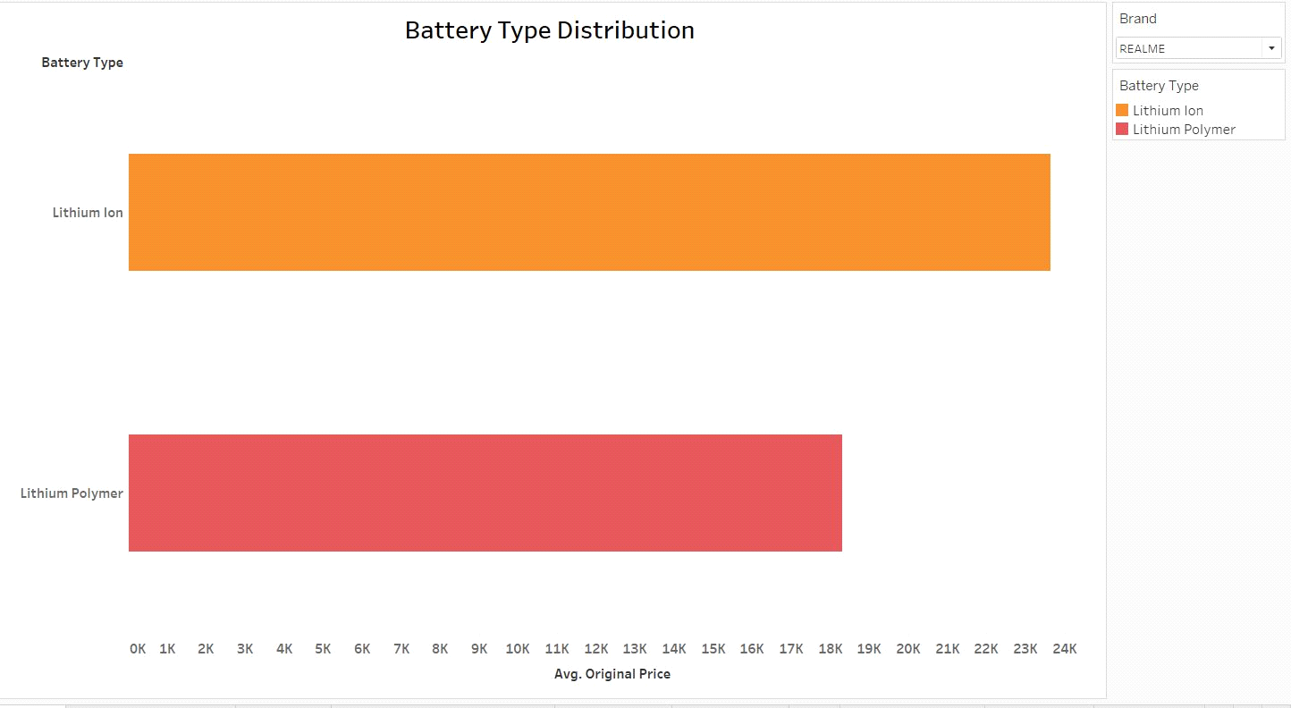

**Activity 3**

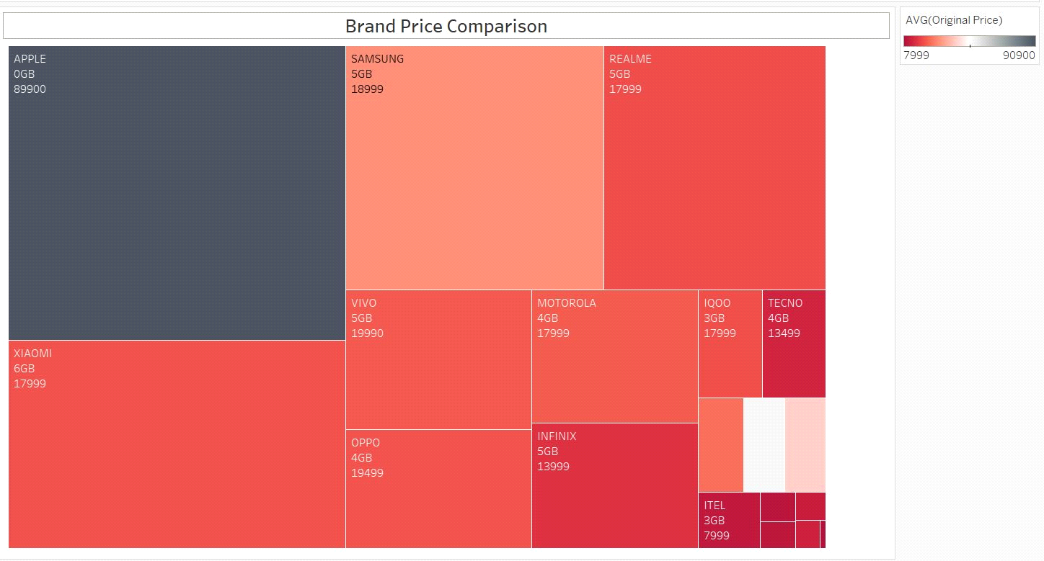

**Activity 4**

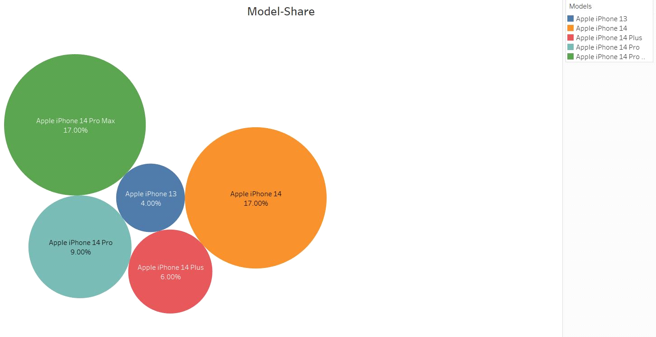

**Activity 5**

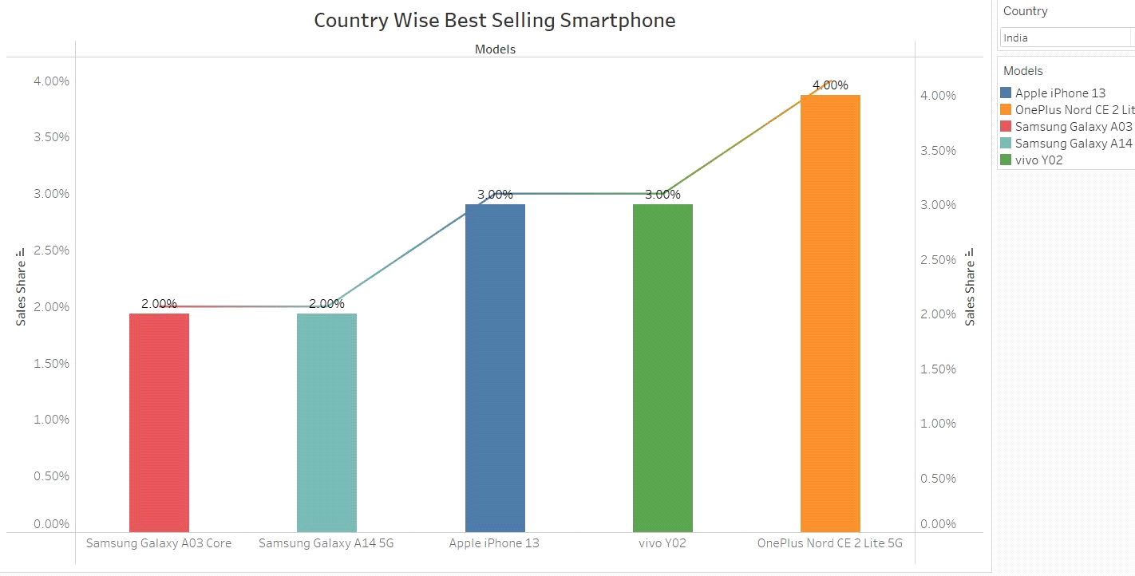

**Activity 6**

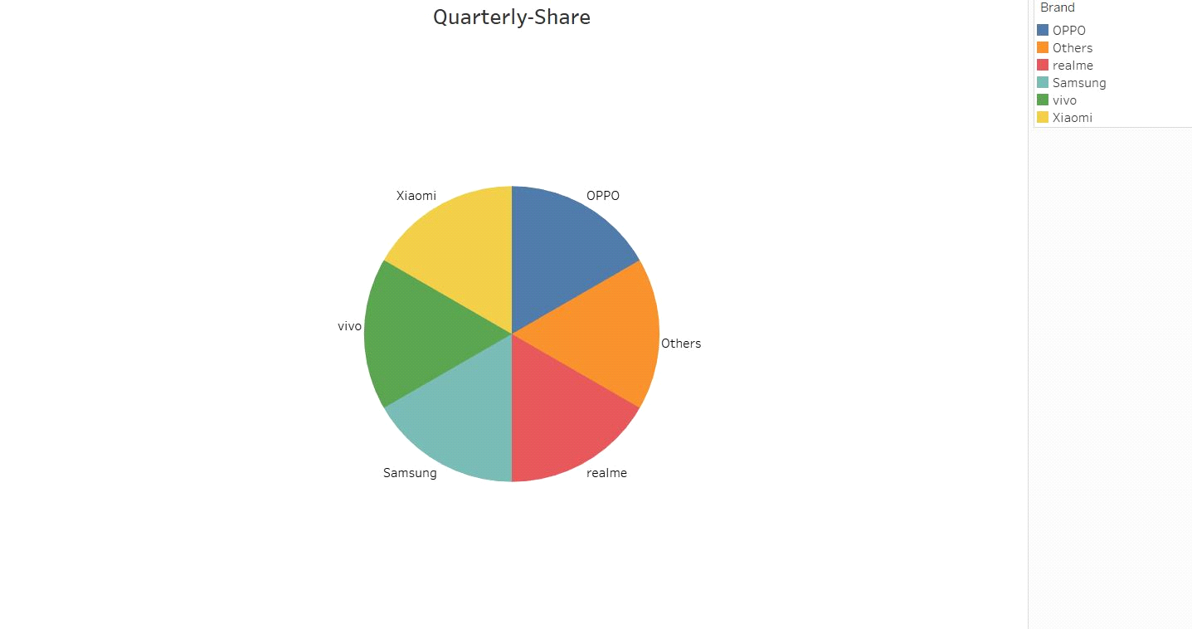

**Activity 7**

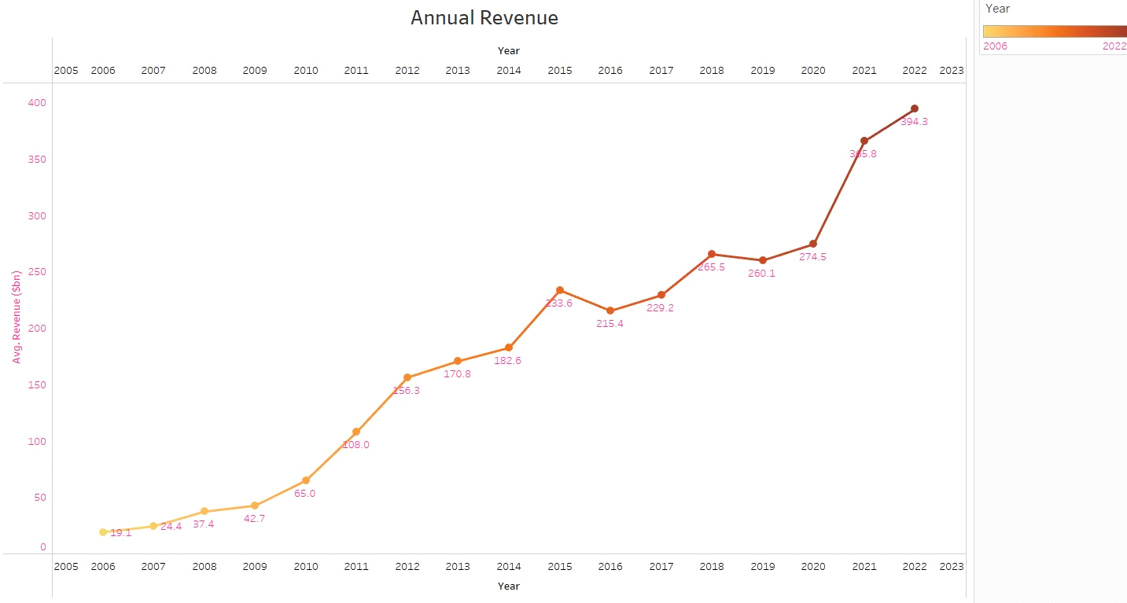

**Activity 8**

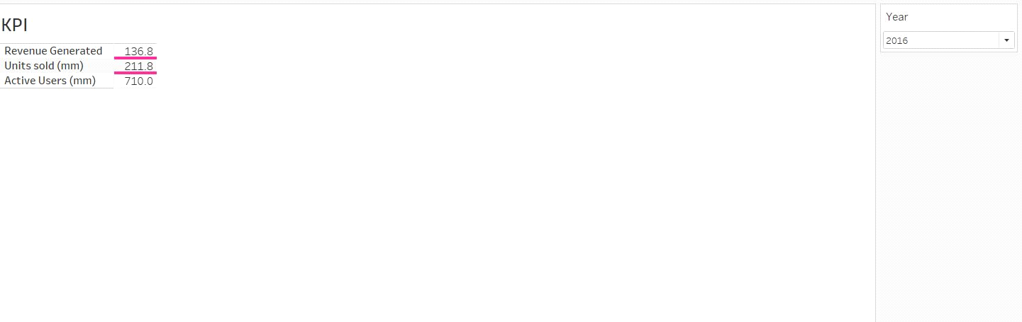

**Activity 9**

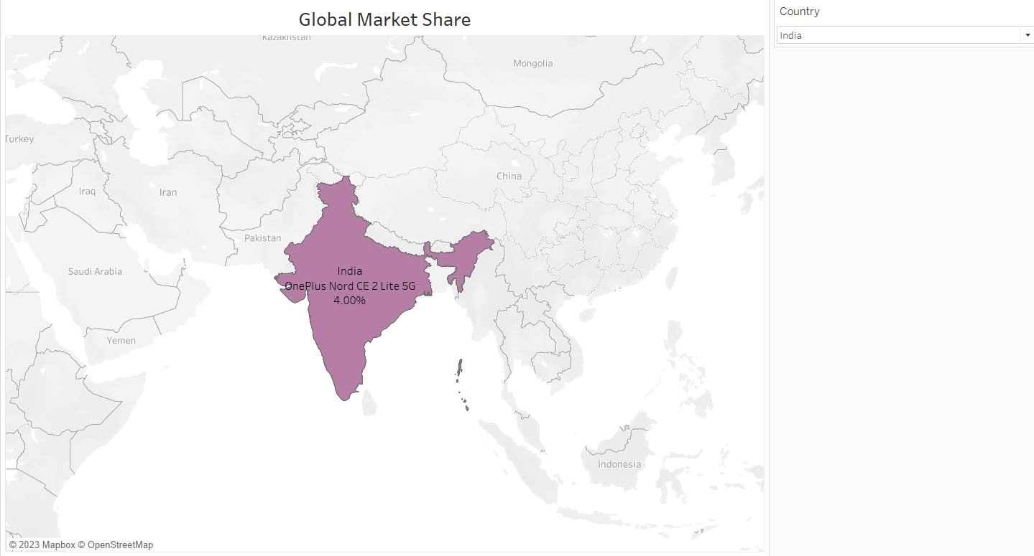

**Dashboard 1**

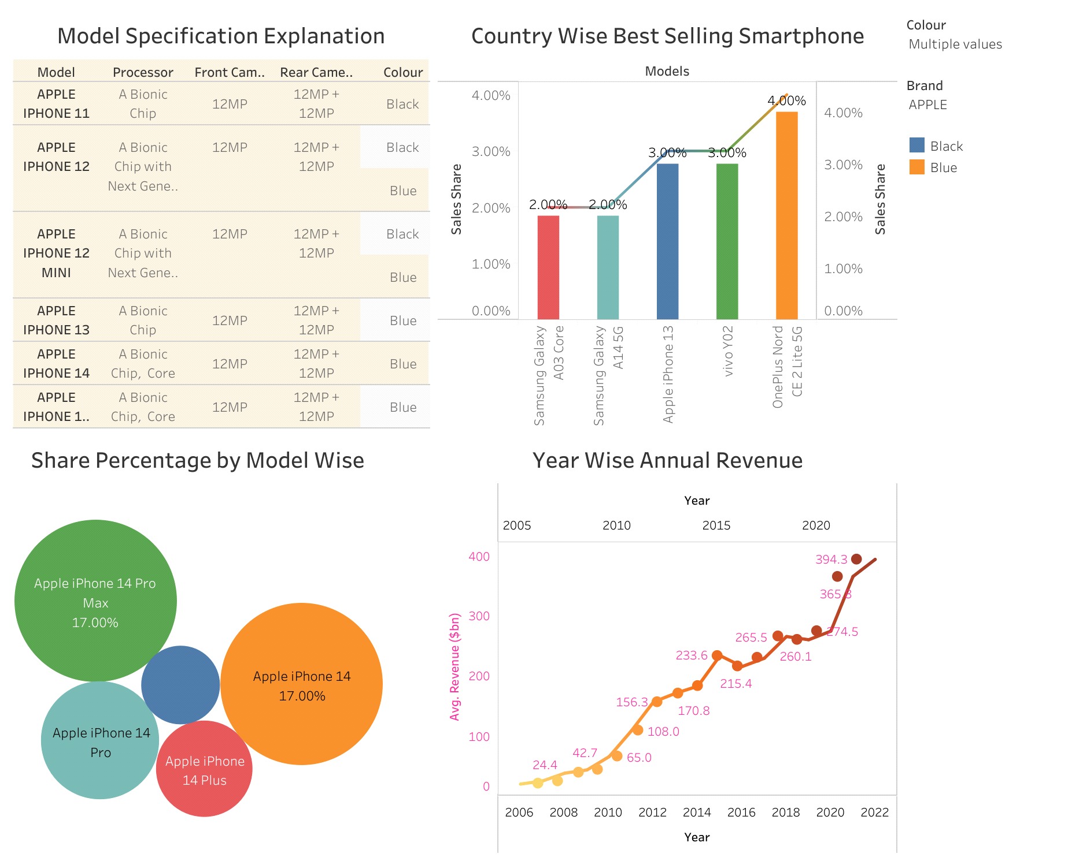

**Dashboard 2**

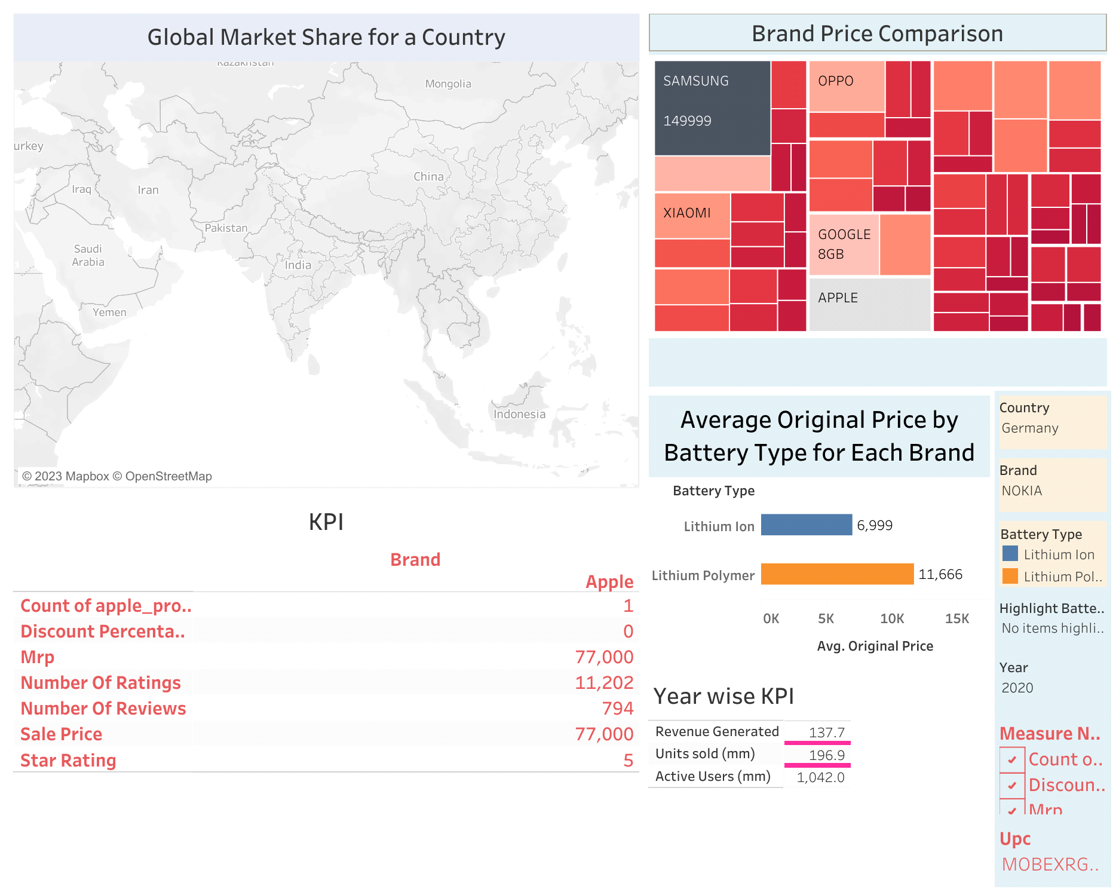

**Story :**

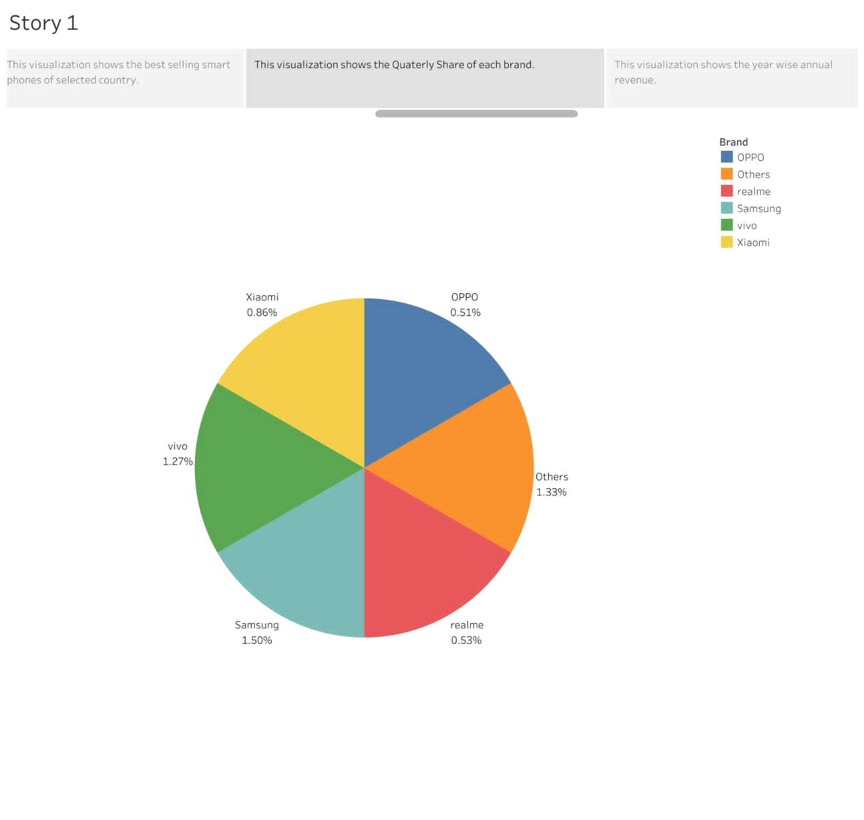

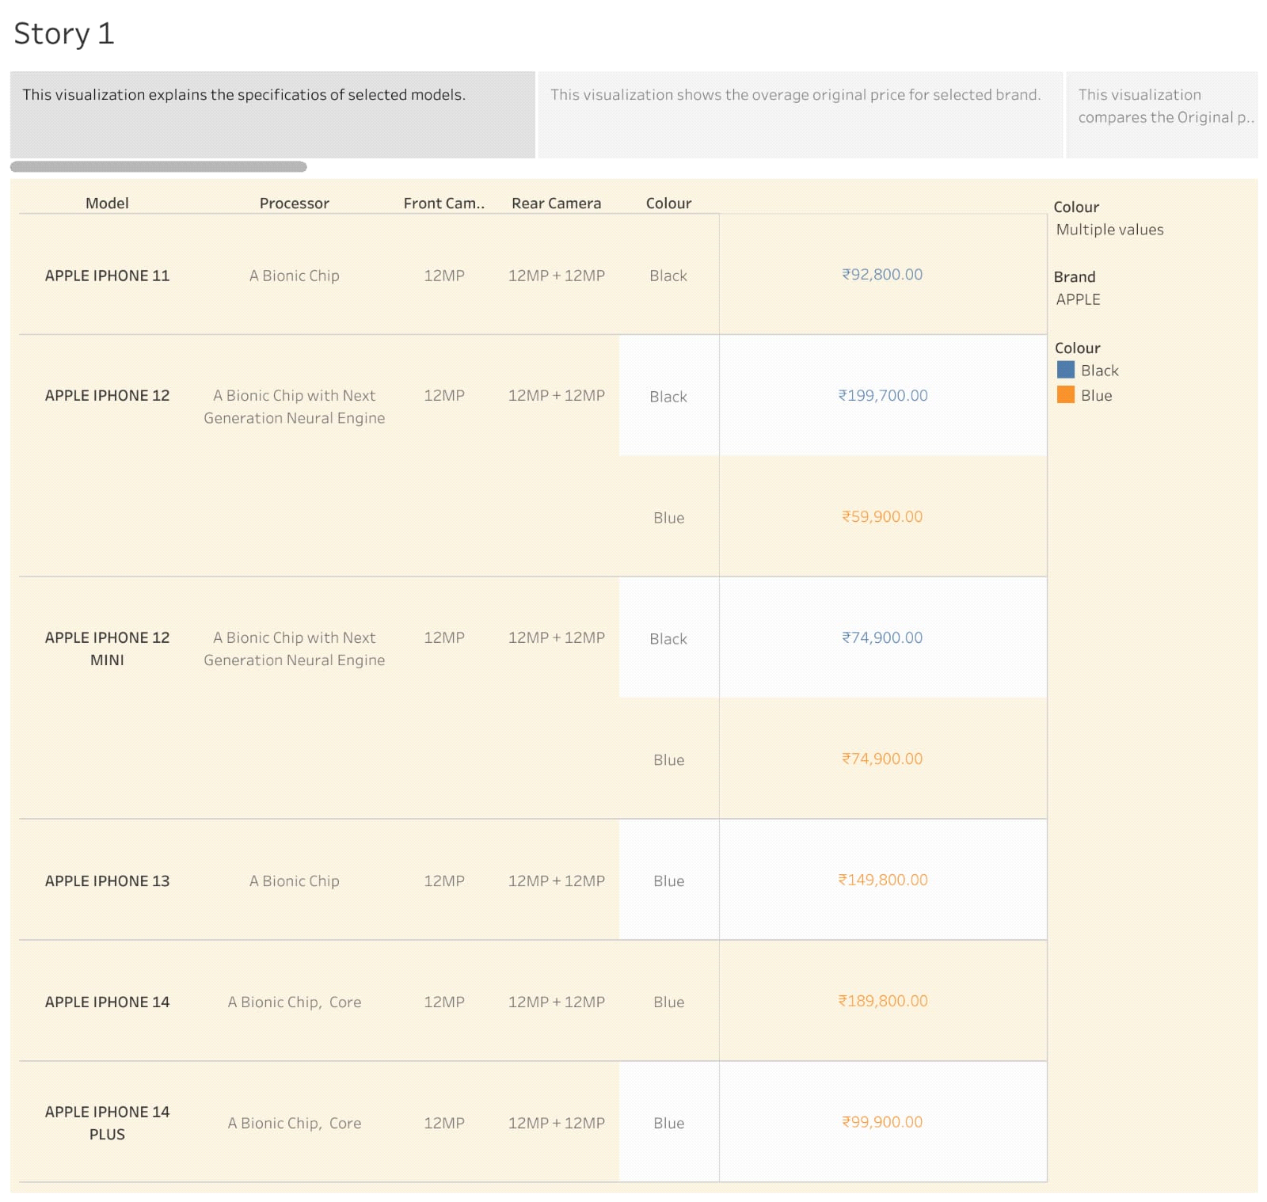

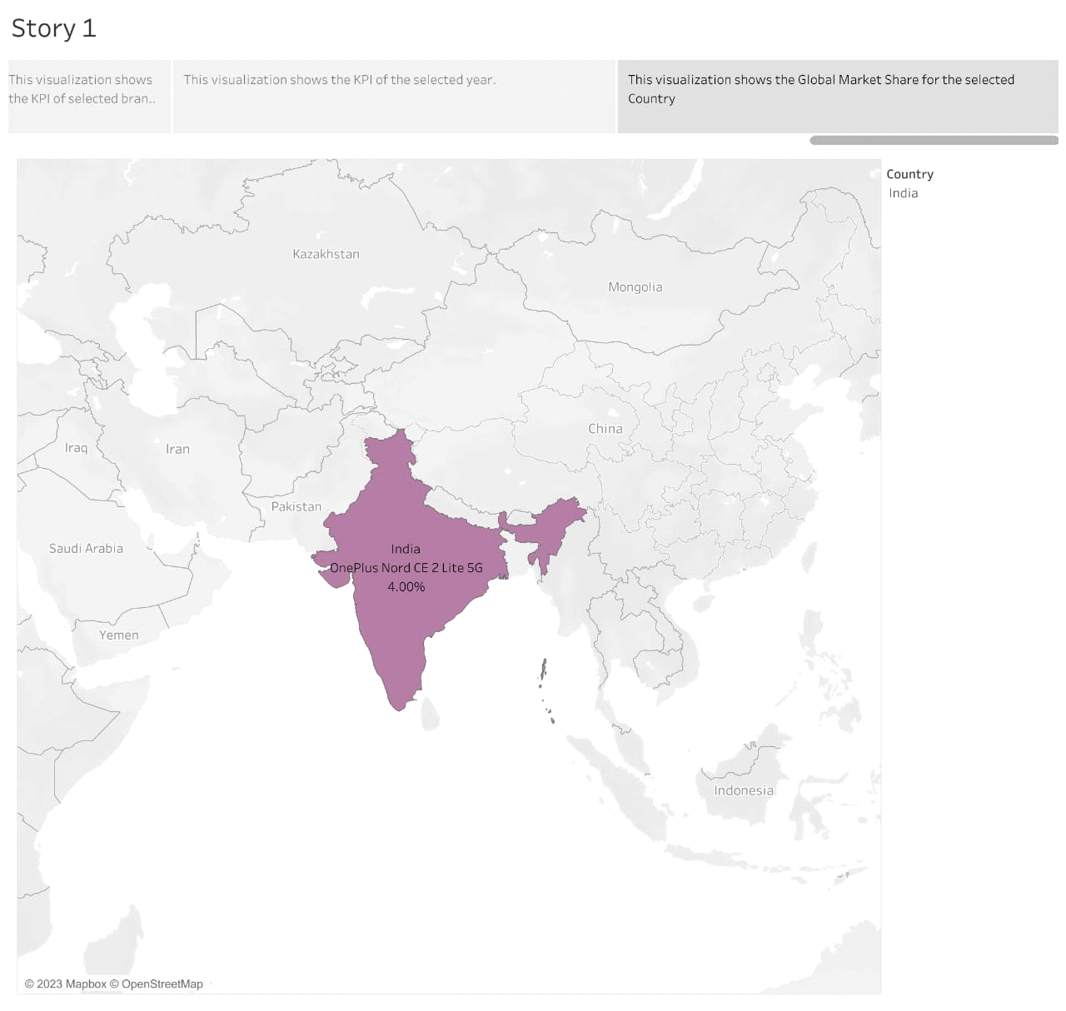

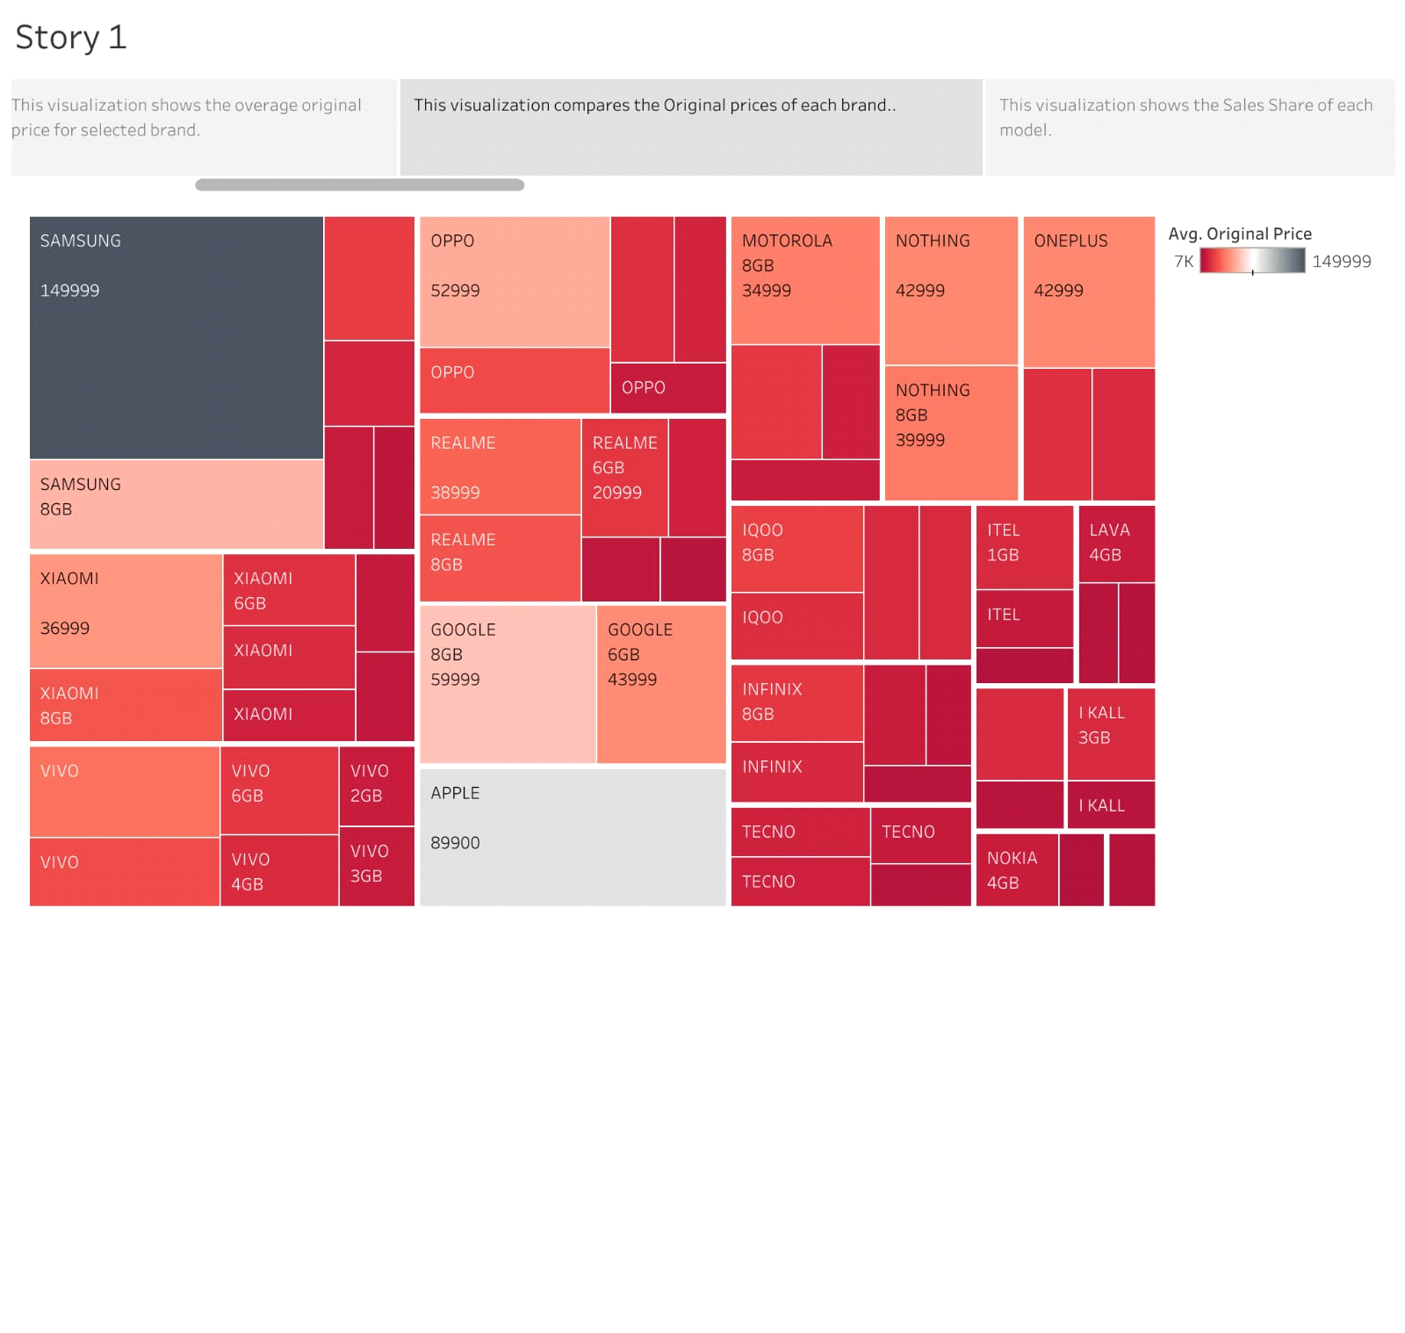

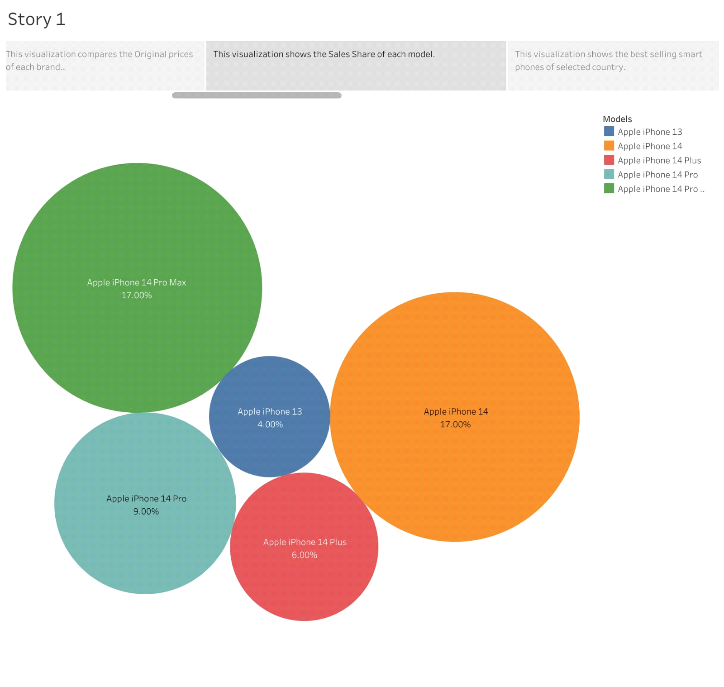

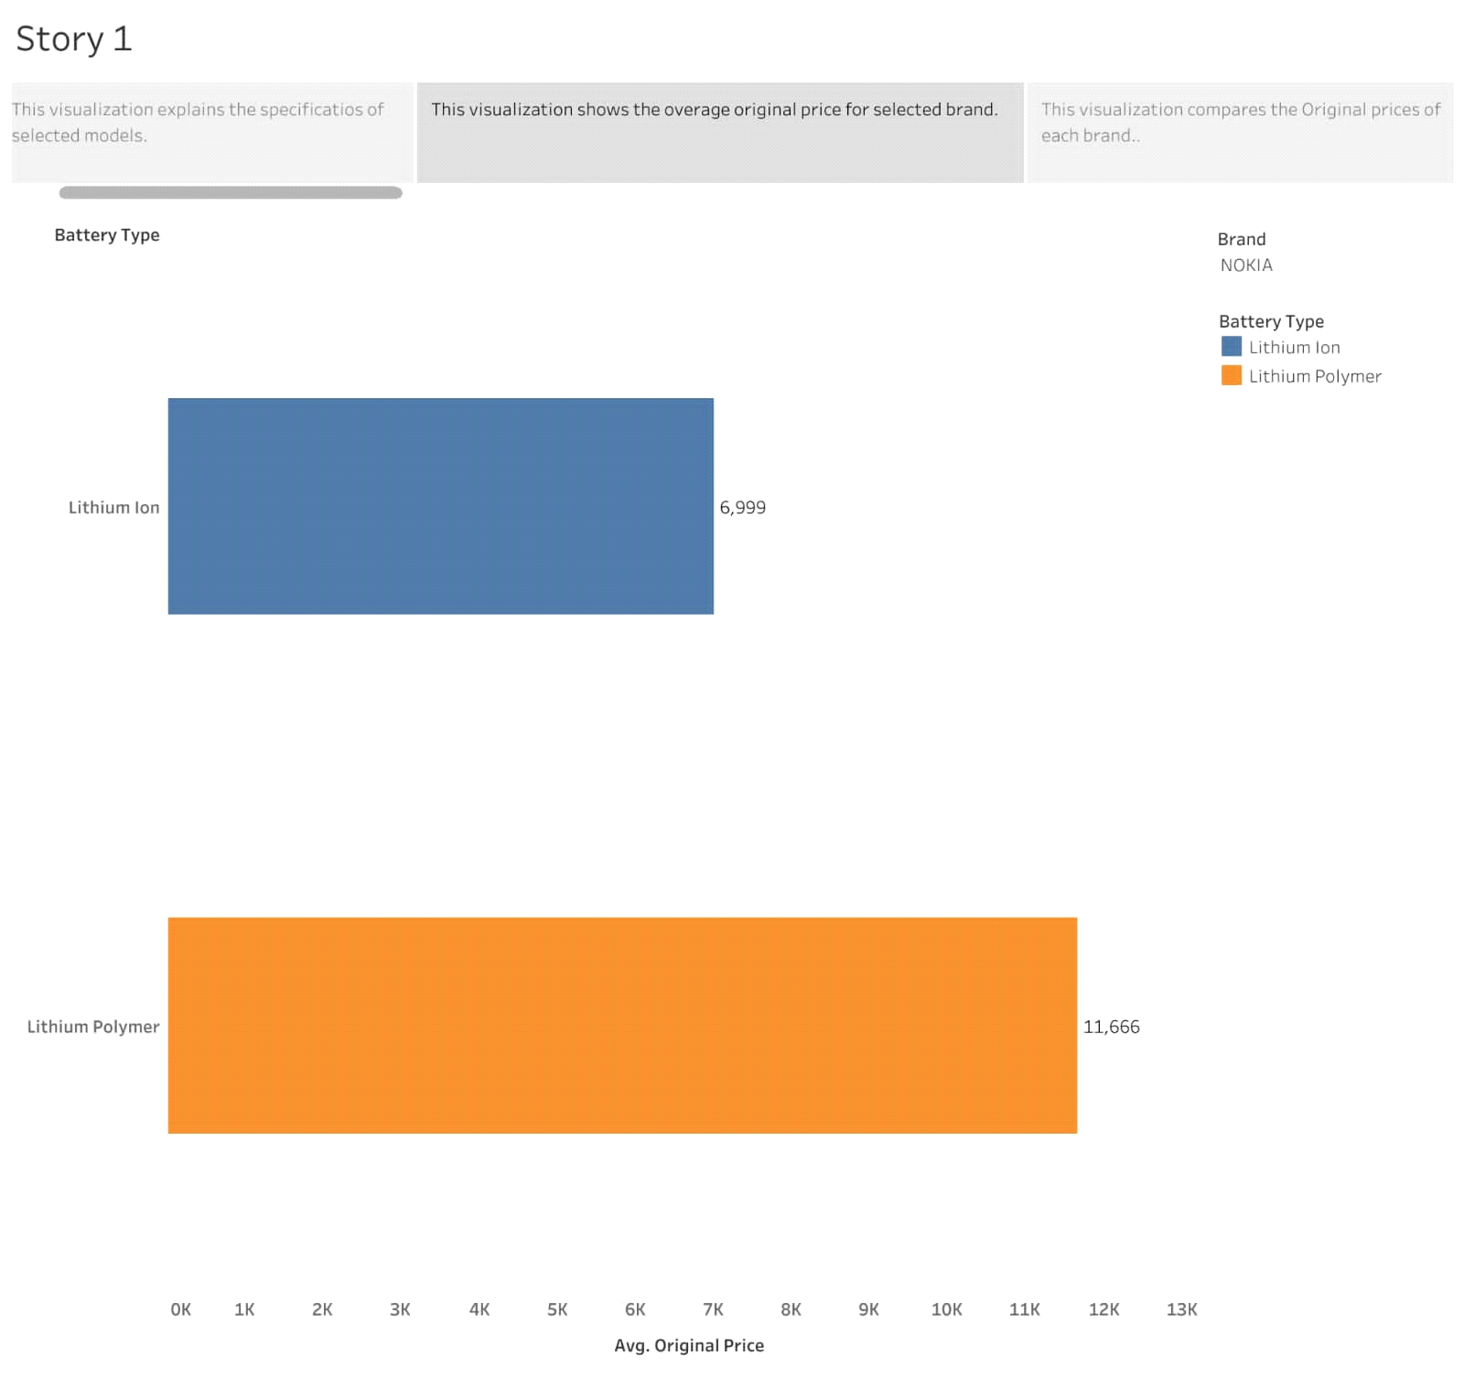

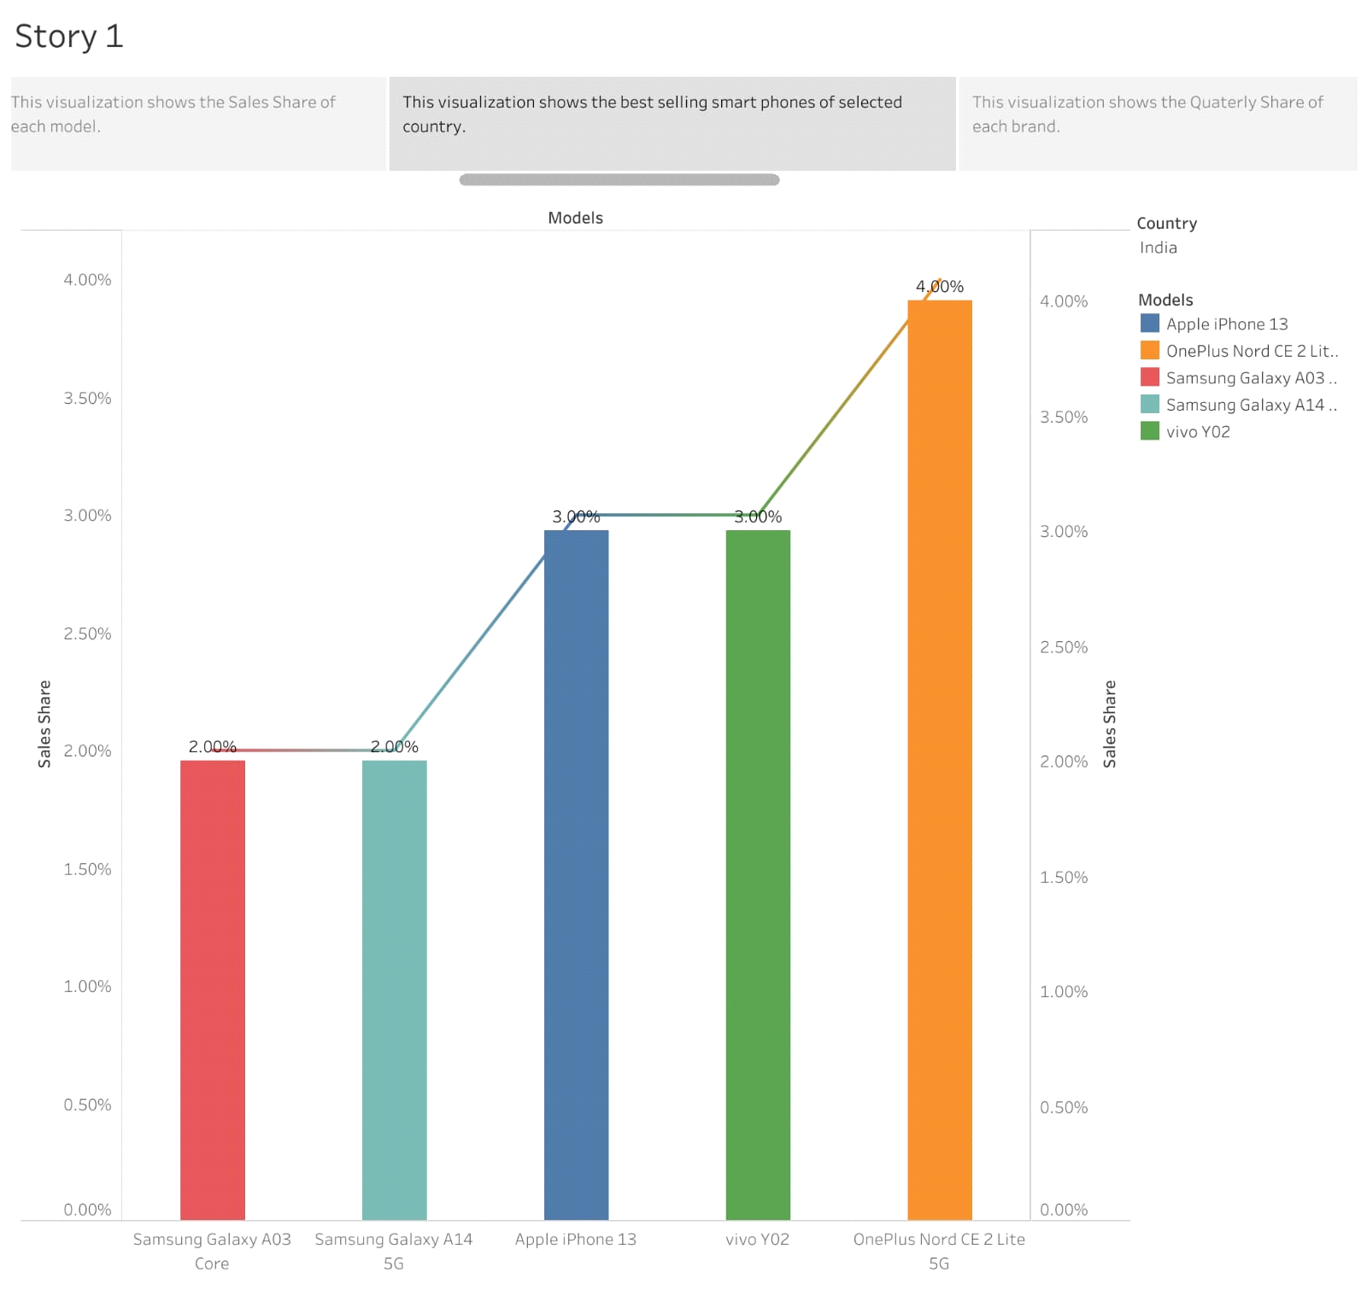

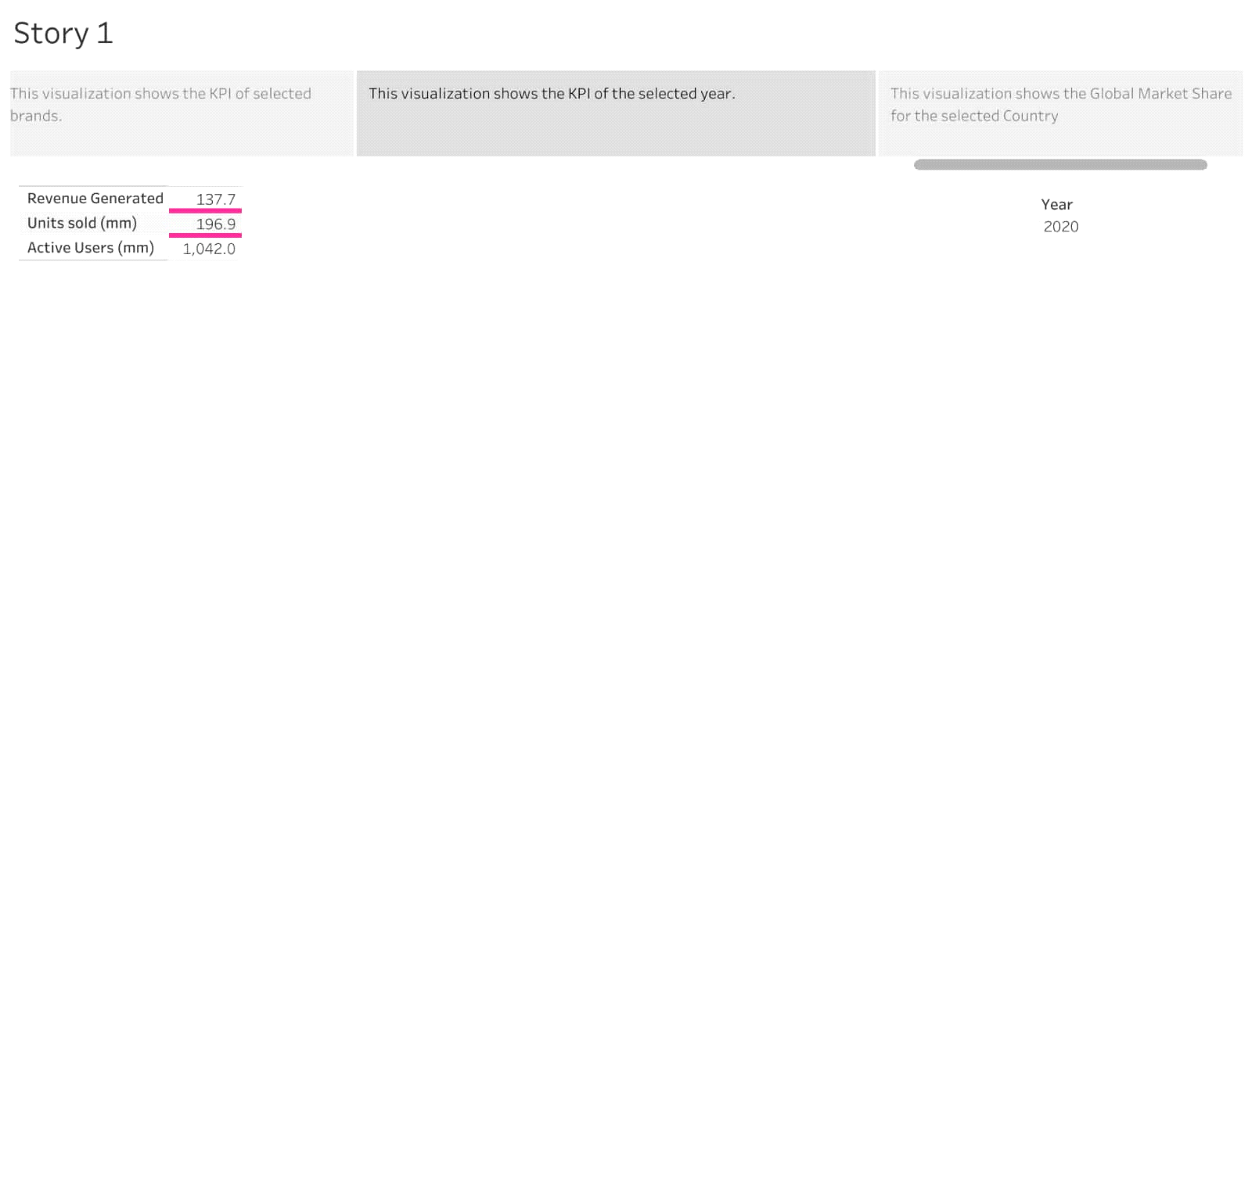

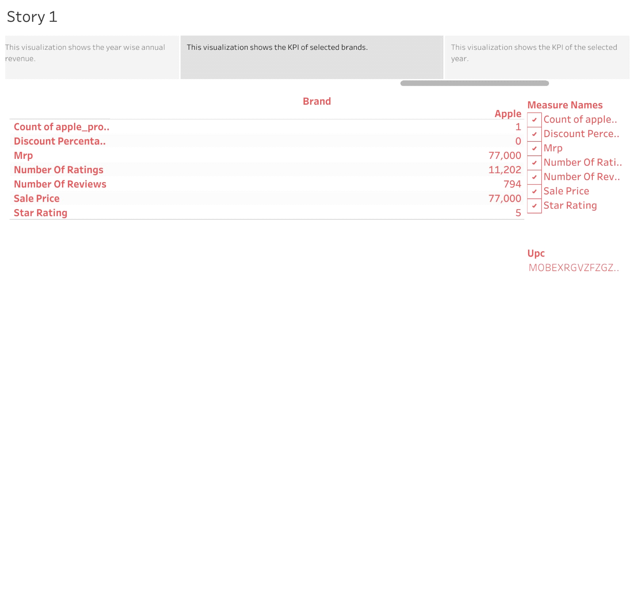

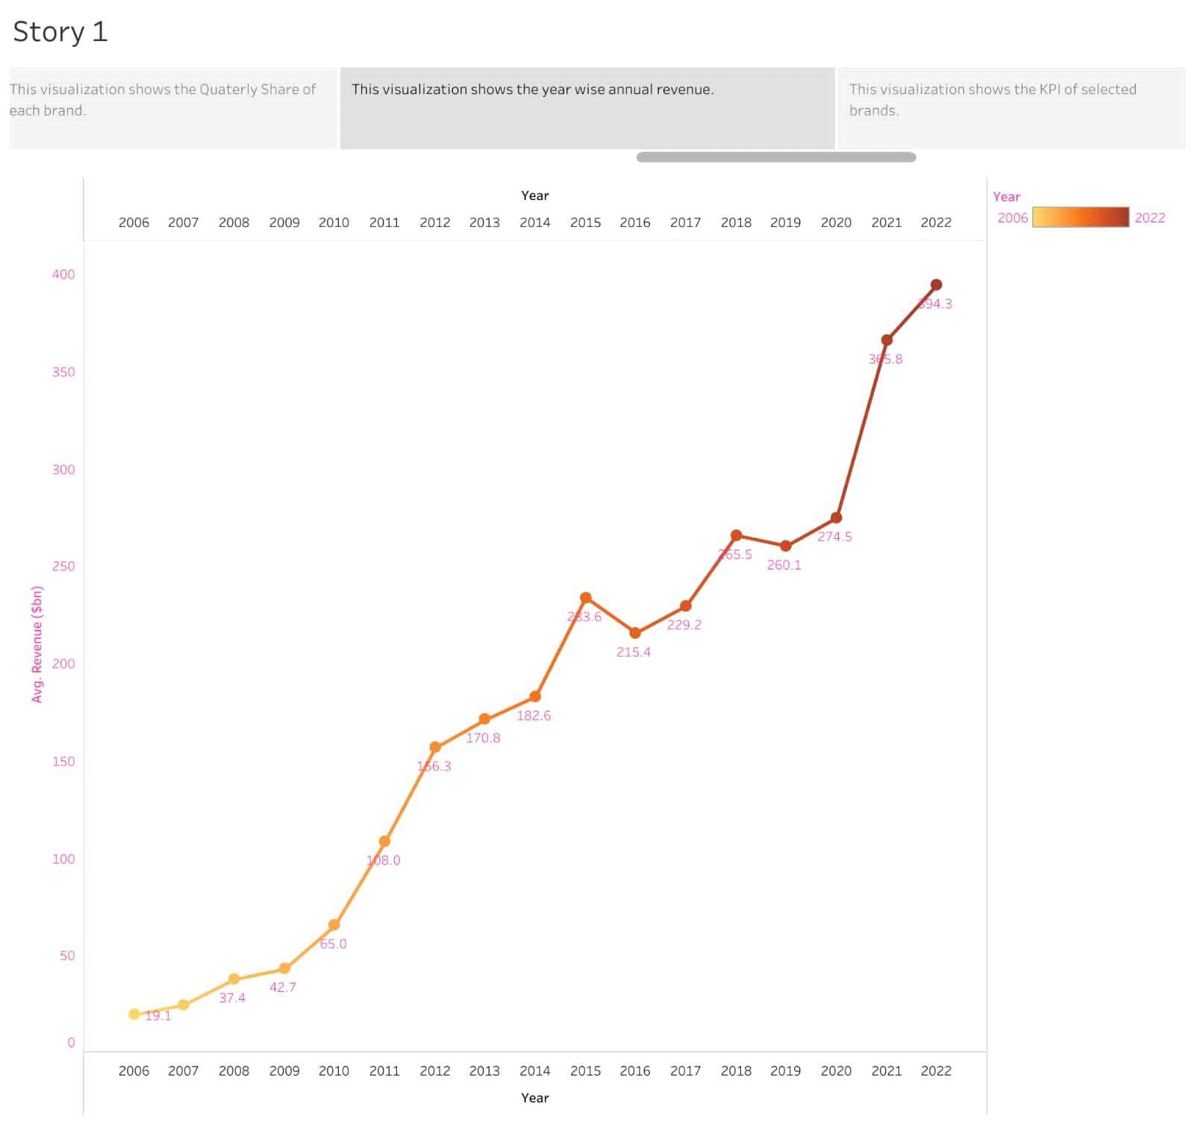

**4 ADVANTAGES & DISADVANTAGES**

This type of analysis enables us to understand the customers choice, annual revenue, best selling modes etc.

**5 APPLICATIONS**

By analyzing the various aspects such as phone models, price and various futures of that model, customers can choose their convenient model.

**6 CONCLUSION**

In this project, we have analyzed the brand wise average price with various facilities, country wises sales, annual revenue of each brand by using tableau.

**7 FUTURE SCOPE**

In future, we can extend our analysis to improve the futures of the phone models with best prices.